**User Interface Design Guidelines**

Applied on Adobe Illustrator

**COMSATS University Islamabad**

Sahiwal Campus



**Usama Sarwar**

FA17-BS(CS)-090-B

**Mr. Awais**

Human Computer Interaction

October 1, 2020

Table of Contents

1. Visibility of System Status 1

2. Match between system and Real World 1

3. User control and Freedom 1

4. Consistency and Standards 2

5. Error Prevention 2

6. Recognition rather than recall 2

7. Flexibility and Efficiency of use 3

8. Help and Documentation 3

9. Aesthetic and Minimalist Design 3

10. Help users recognize, Diagnose and Recover from errors 3

Adobe Illustrator

# Visibility of System Status

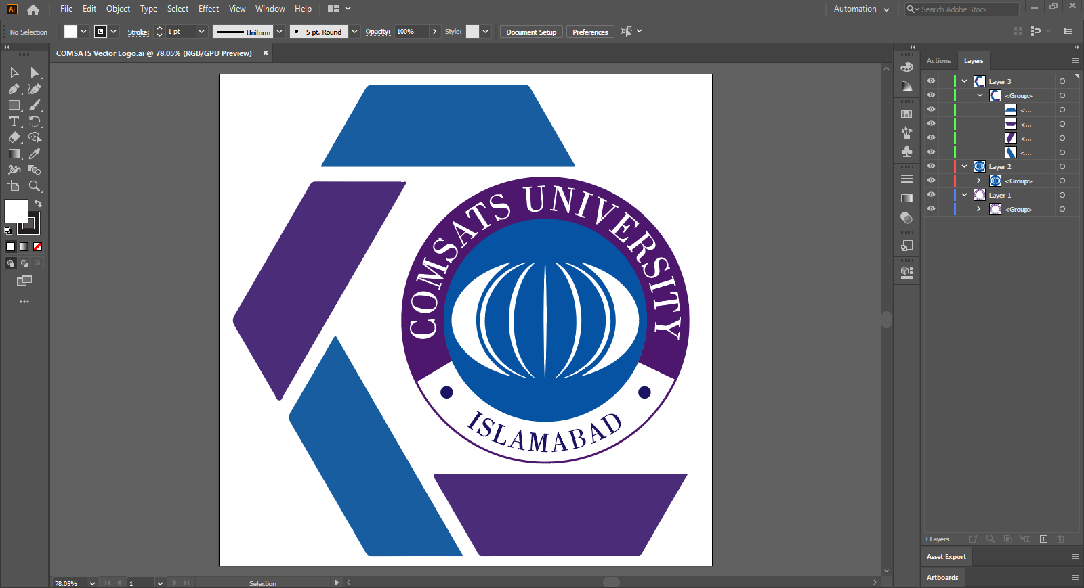

# Match between system and Real World



# User control and Freedom

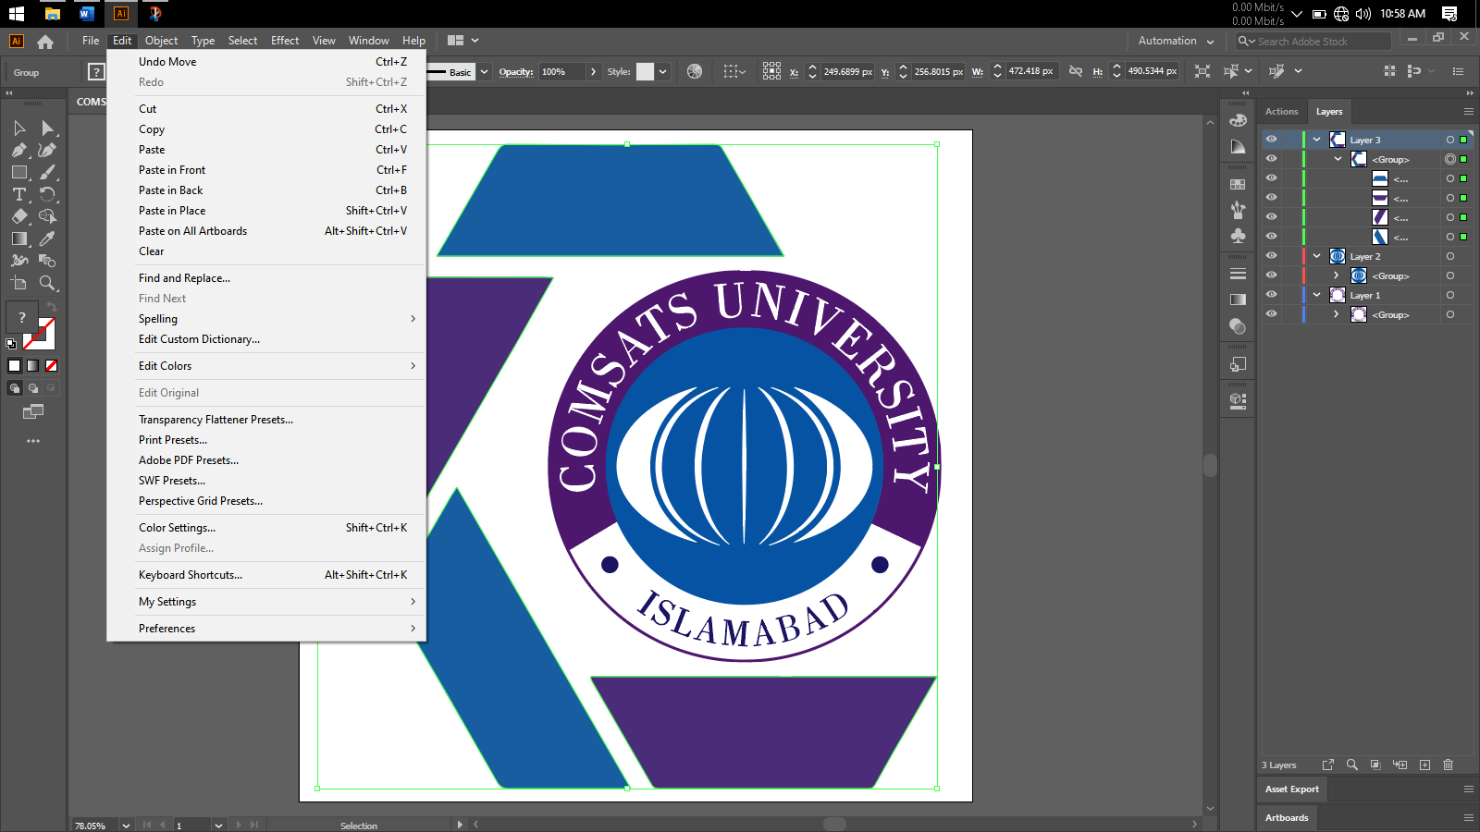

# Consistency and Standards



# Error Prevention

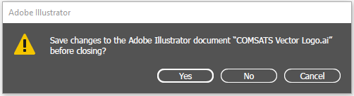

# Recognition rather than recall

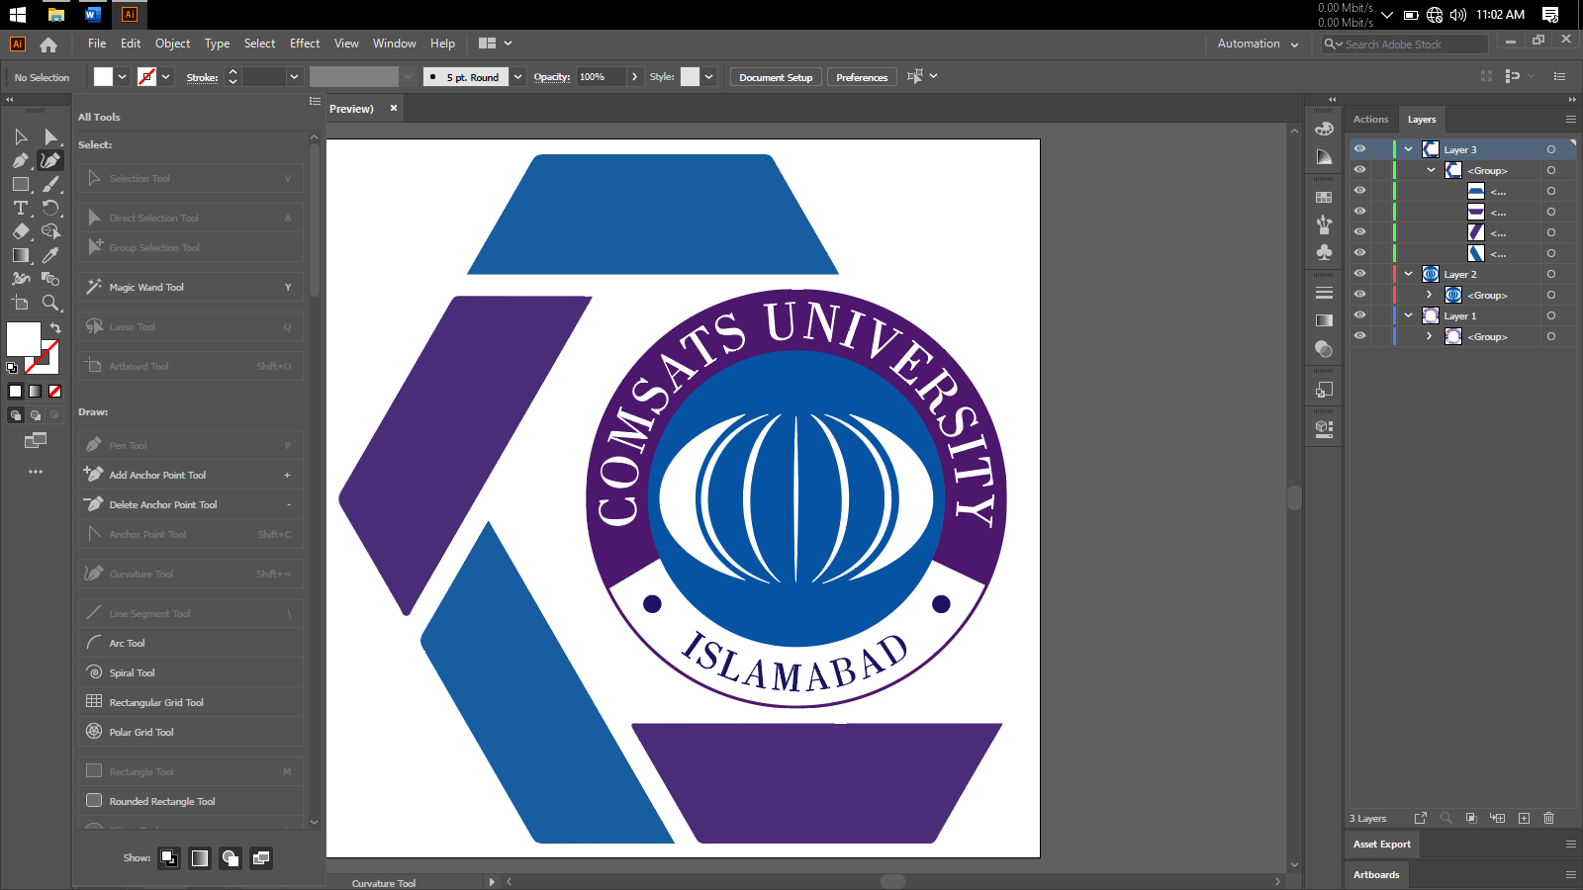

# Flexibility and Efficiency of use



# Help and Documentation

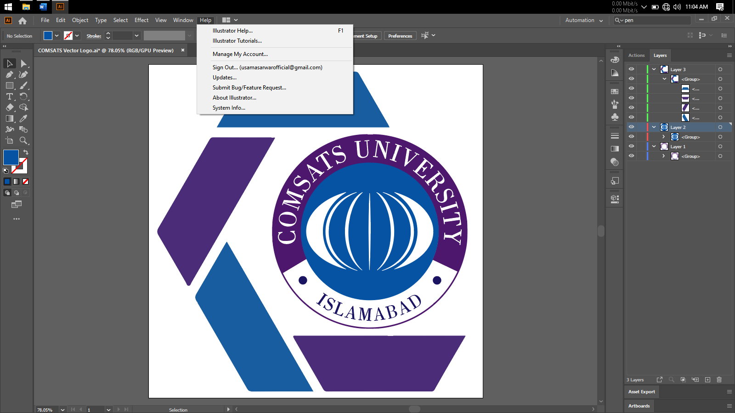

# Aesthetic and Minimalist Design



# Help users recognize, Diagnose and Recover from errors

